MINI CODE LLM MODEL

Architecture :
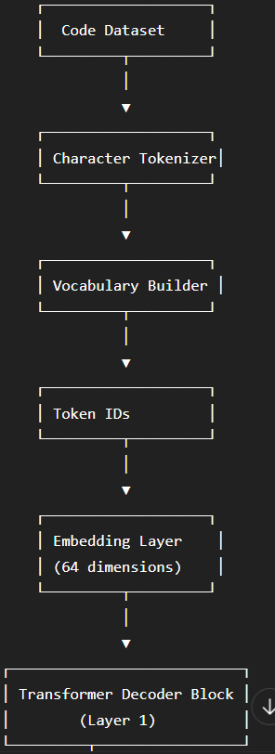

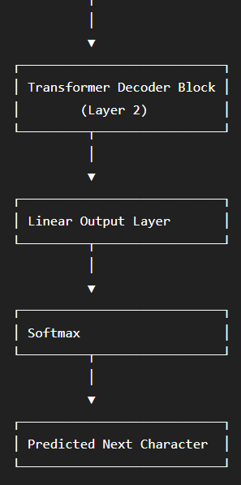

Day 1 work :
Dataset
↓
Tokenizer
↓
Vocabulary
↓
Encoding
↓
Decoding
↓
Verification

DATASET :
A character-level Python code dataset consisting of utility functions, control-flow constructs, data structure operations, string manipulations, mathematical algorithms, exception handling, file operations, and standalone Python programming snippets.

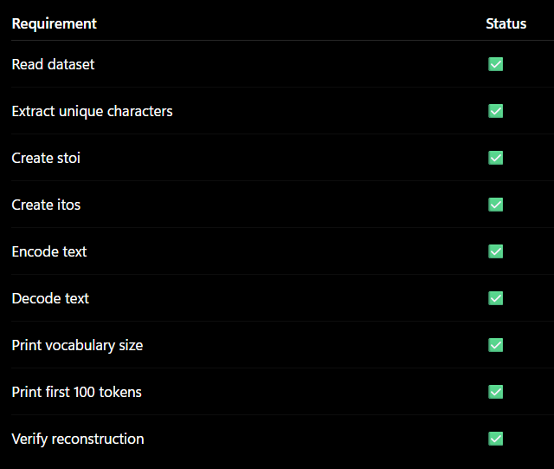
Tokenizer:

